**Fabric Platform**

*User Manual*

**Version 1.0**

**COPYRIGHT NOTICE**

© 2016 Intellect Design Arena. All rights reserved.

This Intellect-branded software and its corresponding documentation are the exclusive property of Intellect Design Arena and are protected under the various copyright laws around the world and by various other intellectual property laws. The use of this software and/or its documentation and any copying thereof by end users is subject to the terms of a license agreement with Intellect Design Arena. The wrongful use or copying of this software and/or documentation subjects infringers to both criminal and civil liabilities.

The trademarks are owned by Intellect Design Arena Pvt Ltd, protected internationally and used by Intellect Design Arena pursuant to an exclusive license. All other trademarks, service marks, and trade names referenced herein are the property of their respective owners.

Any use, copying, reproduction, alteration, transmission, or translation of these materials, in whole or in part, in any form or by any means, is strictly prohibited without the prior written permission of Intellect Design Arena Pvt Ltd. If this material is provided with software licensed by Intellect Design Arena, the information herein is provided subject to the terms of the warranty provided with the product license. If this material is not provided with licensed software, the information herein is provided ‘as is’ without warranty of any kind. In either Case, there are no other warranties, either express or implied, including, but not to the implied warranties of merchantability, fitness for a particular purpose, non-infringement, or quality. In no event shall Intellect Design Arena or any of its affiliates be liable for any direct or indirect, special, incidental, consequential, punitive, or exemplary damages arising out of the use or inability to use the materials and/or information contained herein. Some jurisdictions do not allow the exclusion of implied warranties, so the above exclusion may not apply to you.

Intellect Design Arena takes reasonable measures to ensure the quality of the data and other information produced herein. Although Intellect uses its best endeavors to ensure accuracy of the contents, Intellect assumes no responsibility for any inadvertent error or omission that may appear in this document. Information may be changed or updated without notice. Intellect Design Arena has no obligation to update these materials based on changes to its products or services or those of third parties. Intellect Design Arena may also make improvements or changes to the products or services described in this information at any time without notice.

Intellect Design Arena frequently releases new versions and updates to its software, and therefore images shown in this document may be slightly different from what you see on your screen.

As with any security product, Intellect Design Arena highly recommends the back up of data as well as passwords on a regular basis. Intellect Design Arena is not responsible for the loss of passwords or data that cannot be retrieved based upon a user’s failure to adhere to stringent backup and safekeeping conventions.

**Revision History**

|  |  |  |  |  |  |  |
| --- | --- | --- | --- | --- | --- | --- |
| **Version No.** | **Change Reference No.** | **Author** | **Published Date** | **Sections Changed** | **Description of changes** | **Reviewed By** |
| 1.0 | NA | B. Swathi Kumari | May 12th 2017 | NA | New Document |  |

**Table of Contents**

1. Introduction 4

1.1 Purpose 4

1.2 Scope 4

1.3 Acronyms and Abbreviations 4

1.4 Function of Buttons 5

2. Log-In Procedure/Screen 6

2.1 Step to access Fabric Platform application 6

2.2 Reset password 6

2.3 Sign Up 7

3. App (Dashboard) 11

4.1 App Administration 11

4. APIs (Dashboard) 18

5. System Admin 19

6. Tenant Admin 23

7. Account Management 25

## 

**Cloning this version in GIT**

## Introduction

**Fabric Platform** is a cloud based application that consists of different Apps/APIs integrated on one platform. This unified type of App/APIs helps customer to choose the required one to fix their computational problems.

Product Access is categorized into three roles:

* **SysAdmin:** Has capability to create, edit, and delete any information while configuring the App settings or permissions to the multiple Tenants.
* **TenantAdmin:** Has capability to add/edit information of multiple users within the organization.
* **Account Management:** Has capability to manage the account such as Making Payments for current dues, changing the plans for app subscription, scheduling future payments, View of API Library, and Analytics.

### Purpose

The user manual explains about the overall functionality of Fabric Platform Application. It explains you about navigating among different screens of the platform application.

### Scope

The main objectives of Fabric Platform application are:

* Access to Fabric Platform that consists of unified apps which gives computational solutions to a customer.
* To configure settings for App Admin, SysAdmin, Tenant Admin, and Account Management levels.

### Acronyms and Abbreviations

Following table provides a list of acronyms and their abbreviations that are used in the document.

| **Acronym/Abbreviation** | **Description** |
| --- | --- |
| DSS | Distribution Solution Suite |
| MQ | Message Queue |
| NA | Not Applicable |

### Function of Buttons

In Fabric Platform application, different buttons perform different functionality as mentioned below:

|  |  |
| --- | --- |
| **List of Options** | **Outcome** |
| Save | Submits and saves the given information – specific to page. |
| Add New App | Allows adding new app. |

**Error Messages:** The system displays warnings and error messages with appropriate levels of narrative description. Messages usually contain the descriptions of the error condition, possible reasons for occurrence, and instructions either for interactive correction or for alternate avenues of investigation.

**Error Handling:** If you enter any incorrect/invalid input during the operation of the system, the system displays error message. Such errors usually arise in on-line system. Whenever the system displays any error or wrong message, the screen displays the message with appropriate levels of narrative description.

## Log-In Procedure/Screen

The process flow begins at the Fabric Platform application login page. Use your login credentials to access the application.

URL: [admin.intellectseecapps.com/Login](https://admin.intellectseeccloud.online/Login)



### Step to access Fabric Platform application

* If you already have an account, provide your login credentials (User Name and Password) and click ‘Sign in’.

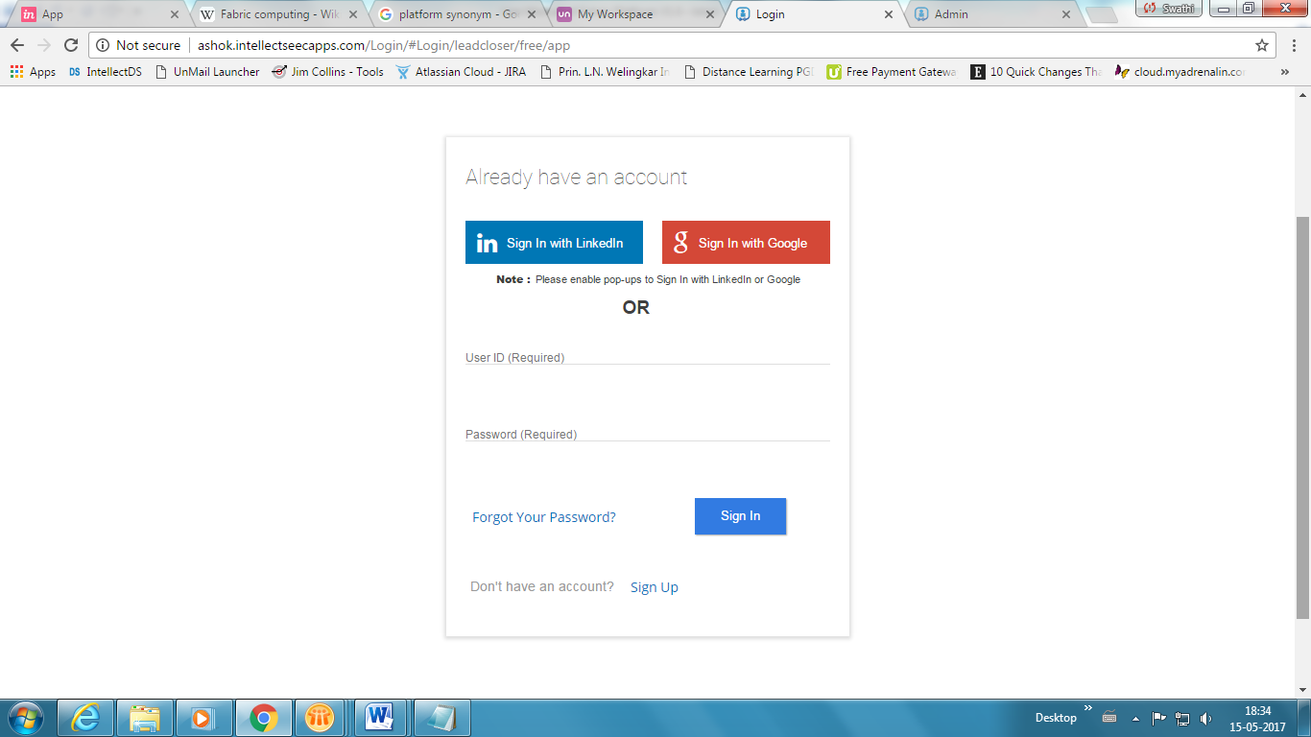

### Reset password

When password is lost or forgotten, ‘Forgot Password’ is used to navigate the following screen where you need to provide your registered ‘Email ID’ and click ‘Request Reset Link’. Check your email for reset link and provide your new password.

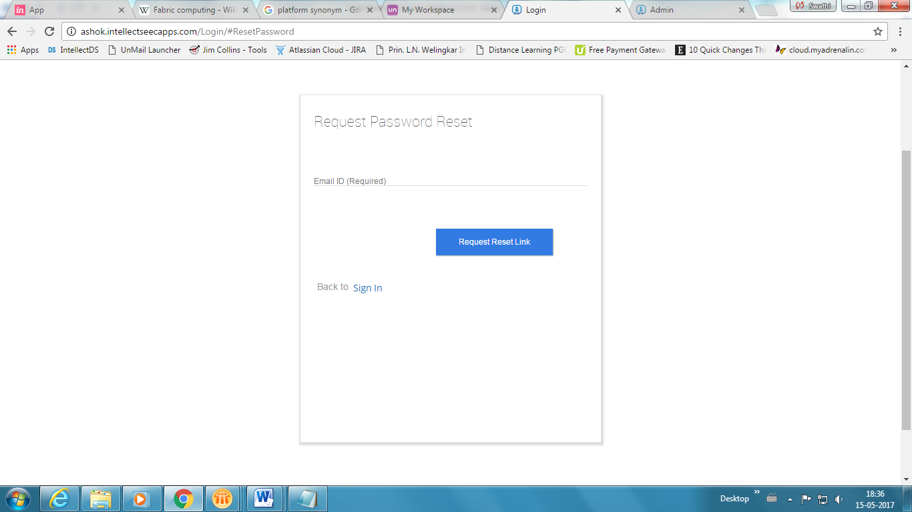

### Sign Up

When you click Sign Up on Login page, the application navigates to Pricing and Plans screen for Distribution Solution Suite.

List of DS apps are displayed in series, click Sign Up button on required app.

**Lead Closer:** To track the stages of an enquiry or consumer interest in to a Lead or Prospect.

**Needs Analysis:** The Needs Analysis is used to determine product options that will assist a lead/customer to meet their identified financial goals.

**Quotes and Illustration:** Quotes helps to estimate the premium that has to be paid by the insured for the agreement with insurance company.

**E-app:** To register for a policy contract electronically.

**Profile Management:** Manage details of the customer such as Personal Information, service related documents etc.

**Customer Servicing:** Allows customer to handle financial and non-financial transactions.

**Product Configurator:** Configure the product featuressuch as Product Details, Coverages, Riders, Benefits and Investment Property Details.

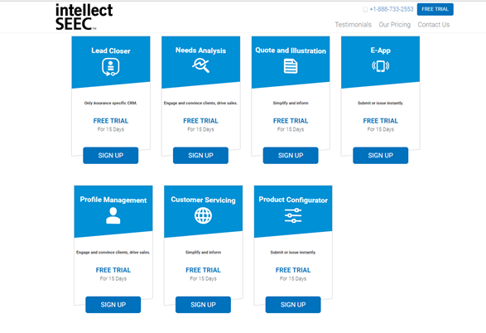

Create your account by giving the required details to register and also subscribe by selecting the plan (Free, Silver, Gold and Platinum) and then click Sign Up.

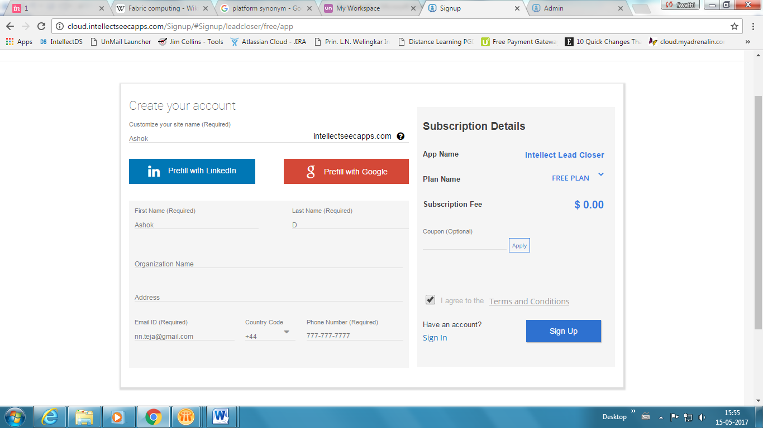

A new window appears with Sign Up confirmation message, Click Sign in now to navigate back to the Login screen.

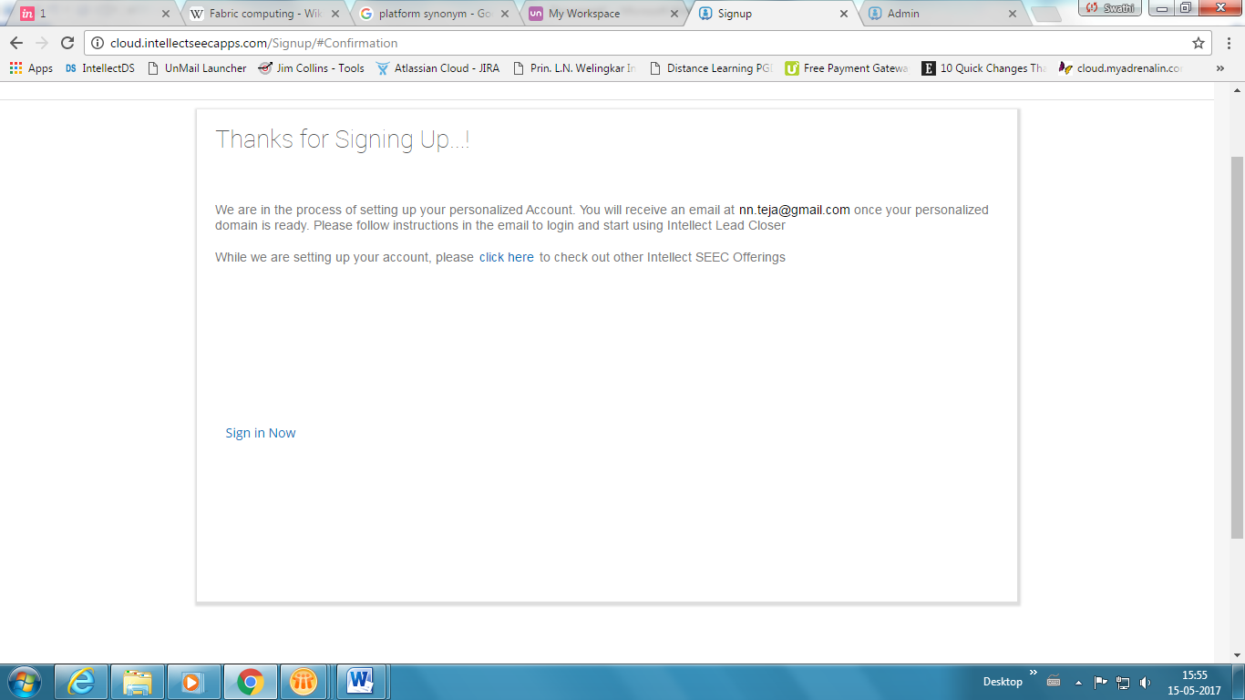

When existing customers click Sign In on Create account page, a new window appears asking for the domain to set. Enter you domain name and then click Set Domain and then Sign In.

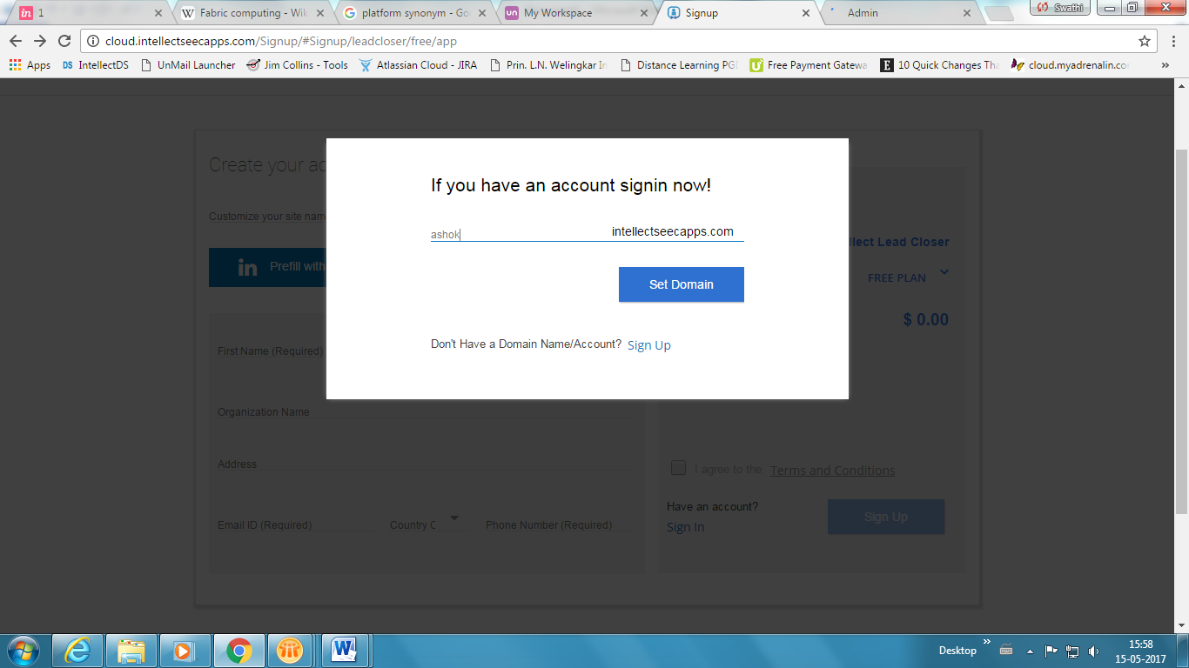

**Common Functions Found in Header:**

* **Invite Colleague:** Invite your colleague by clicking on group  icon and then type First Name, Last Name and E-mail address of the person to whom you would like to send an invitation. Click ‘Add More’ to invite more than one colleague and click ‘Send Invite’.
* **Alerts & Notifications:** The system displays the number of alerts & notifications for the customer that are unread. Notifications display date, time and message. Color change is introduced for immediate follow-up of colored notifications.

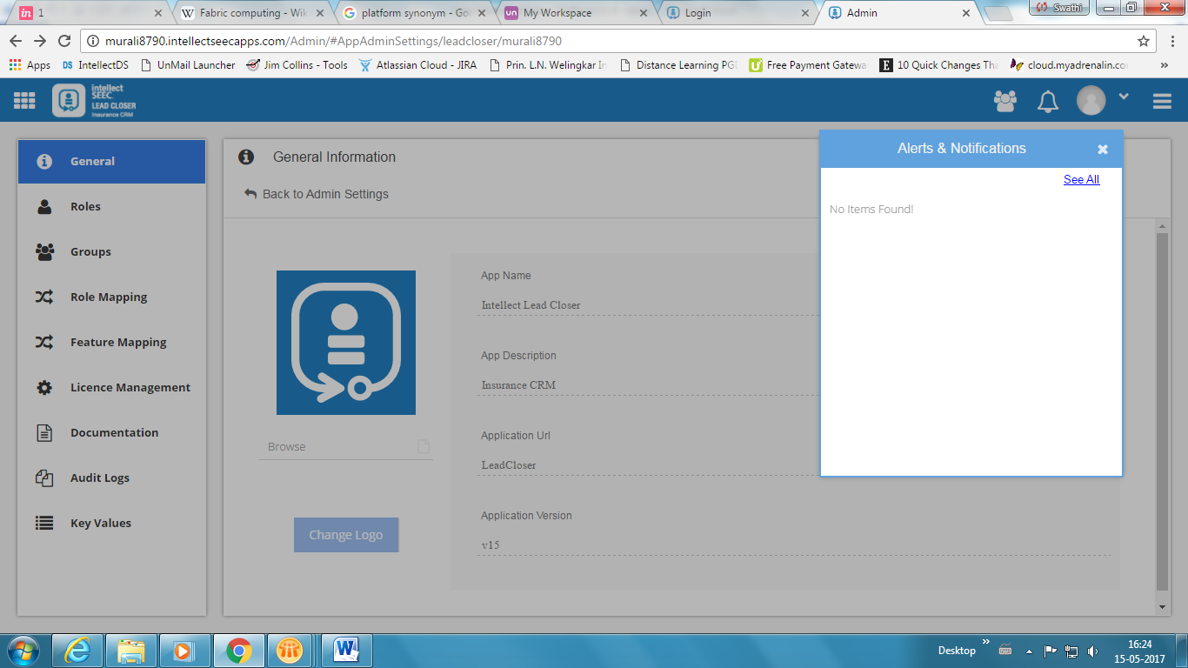

Click See All to view all alerts and notification received and also allows you to refine the results by selecting the check box provided against Alerts or Notifications specific to Date and App.

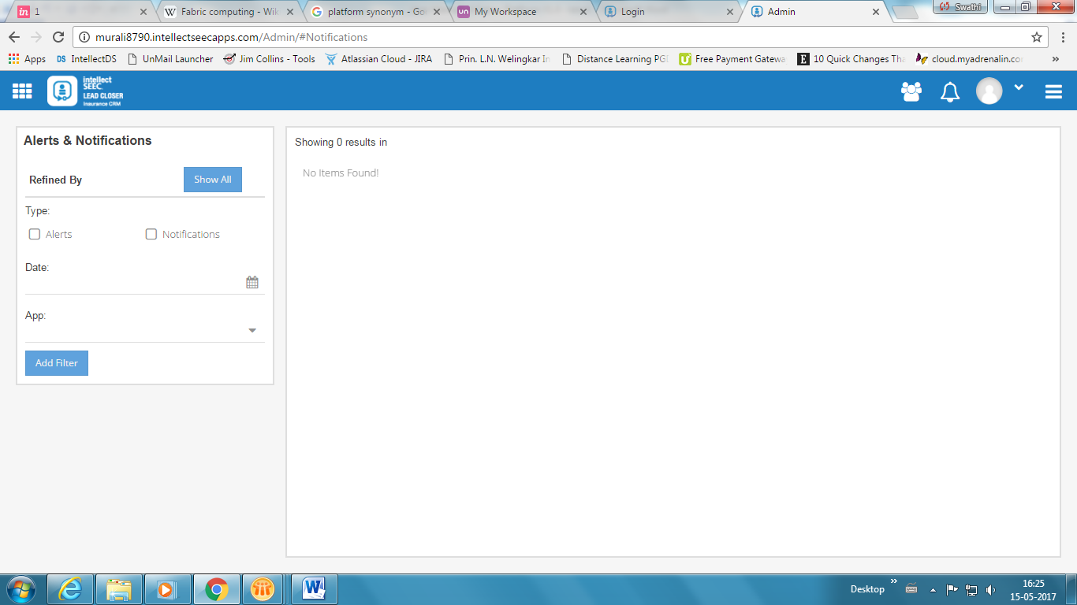

* **Log Out:** End session and navigateto login page.

## App (Dashboard)

In App section all apps are integrated or unified under one platform, the main advantage of this section is the Admin User configuring the App settings for the apps that are existing with the customer and also can connect the new app trial version.

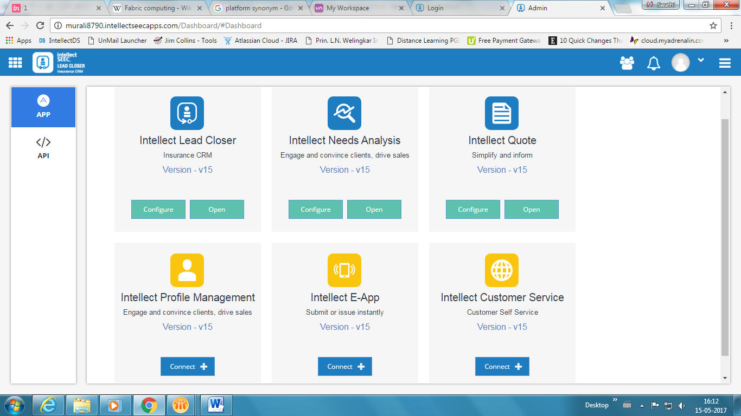

Green check mark is shown on the left hand side of the card for the existing apps and further it allows the admin user to configure the settings by clicking on **Configure** button.



### App Administration

**General:**

General tab consist of the following information such as Application Name, Application URL, Application Version and also allows adding the logo of the Tenant or customer.

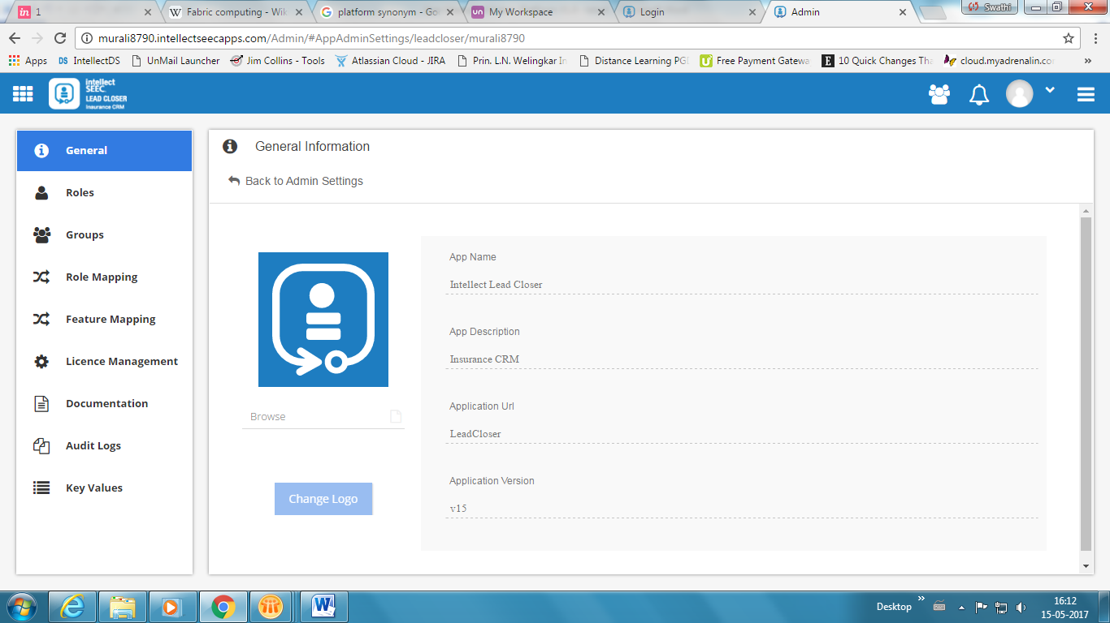

**Roles:**

Click Add New Role, a new window appears on the screen asking to add the role as per the client requirement. 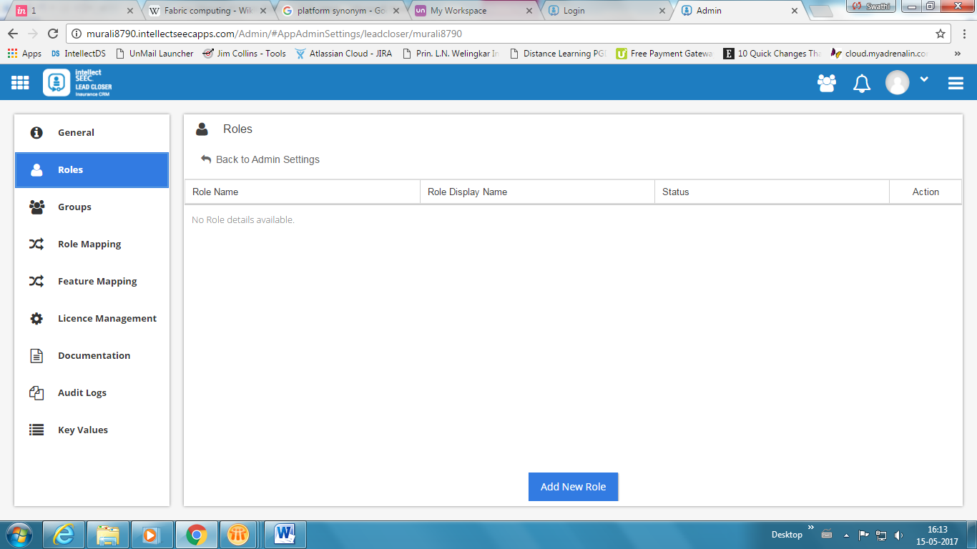

Set the status to active or inactive as required against each role (SysAdmin, Admin, User, Superuser, etc).

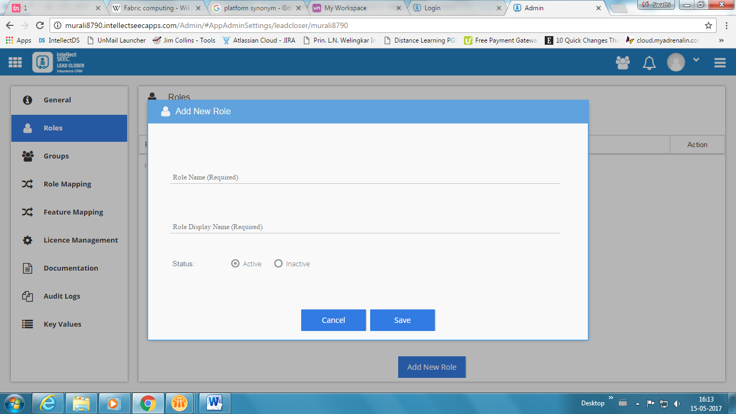

**Groups:**

Click Add New Group, a new window appears which allows you to enter the details of the group as required.

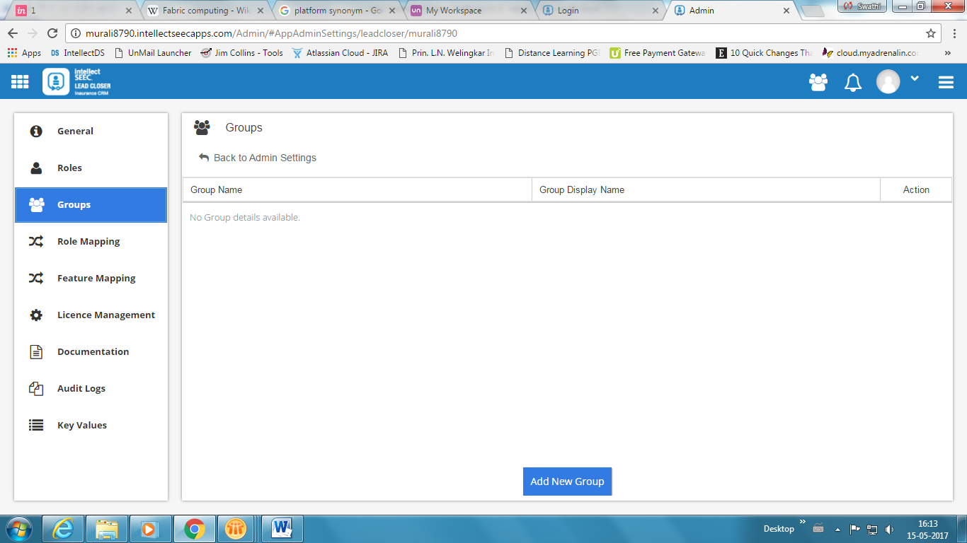

Click Save to add the details of the group created.

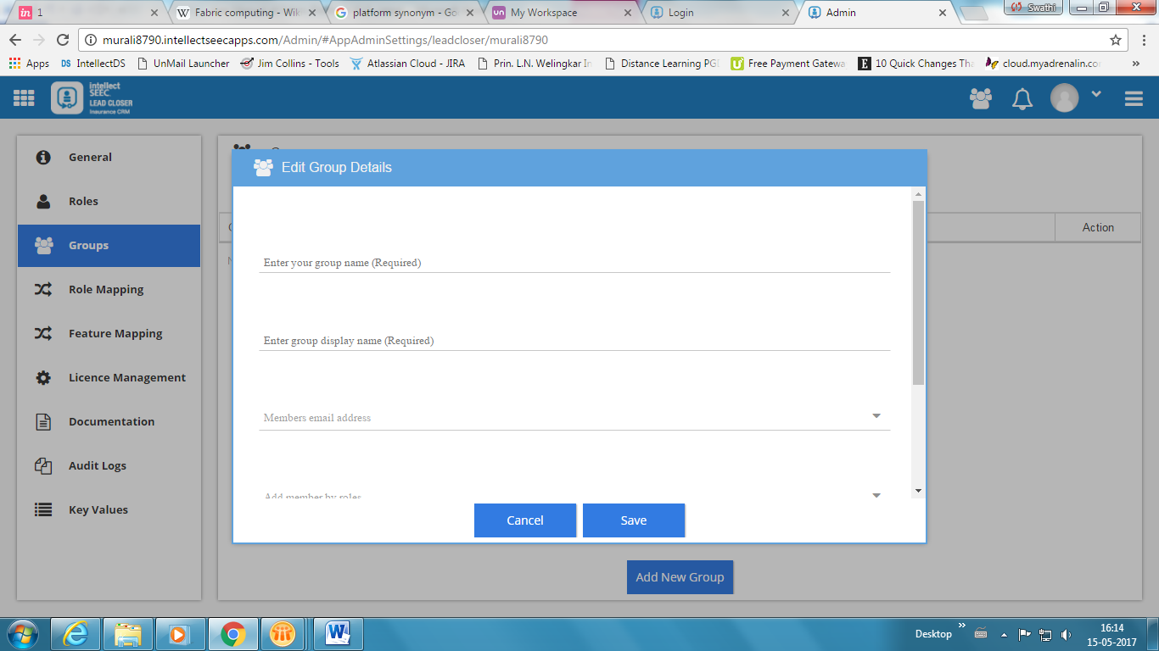

**Role Mapping:**

This is a key step since the users are dynamically mapped to security roles; each organization has different roles with respect to their domain or organization structure. Admin user can map the roles with respect to the inputs given by the client.

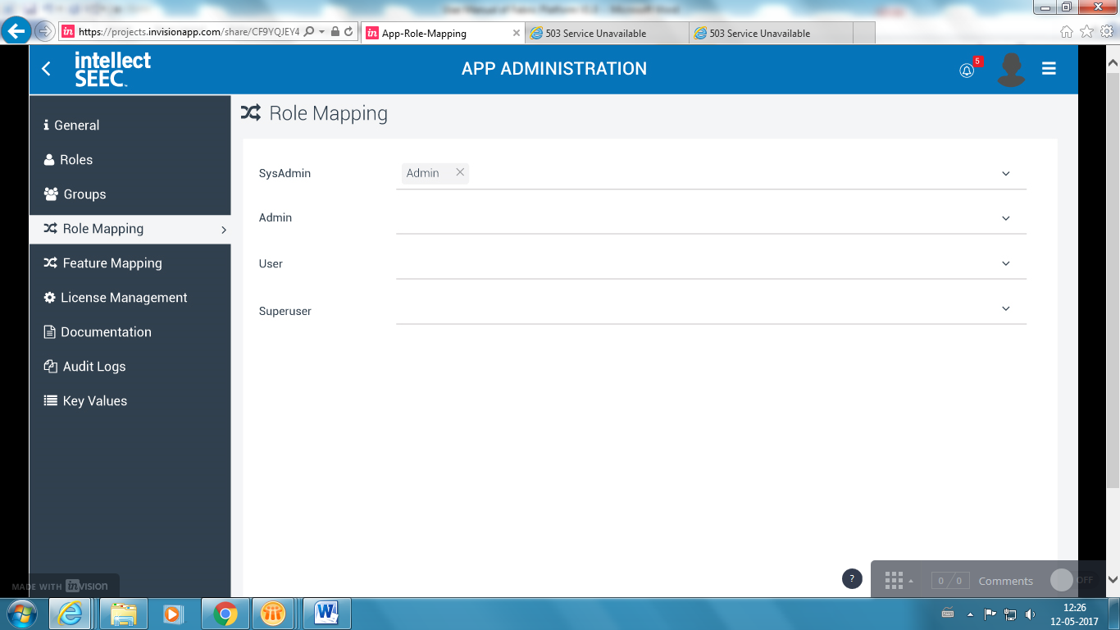

**Feature Mapping:**

Map according to specific roles that will have privileges to configure the settings to other users to Add, Edit, and View.

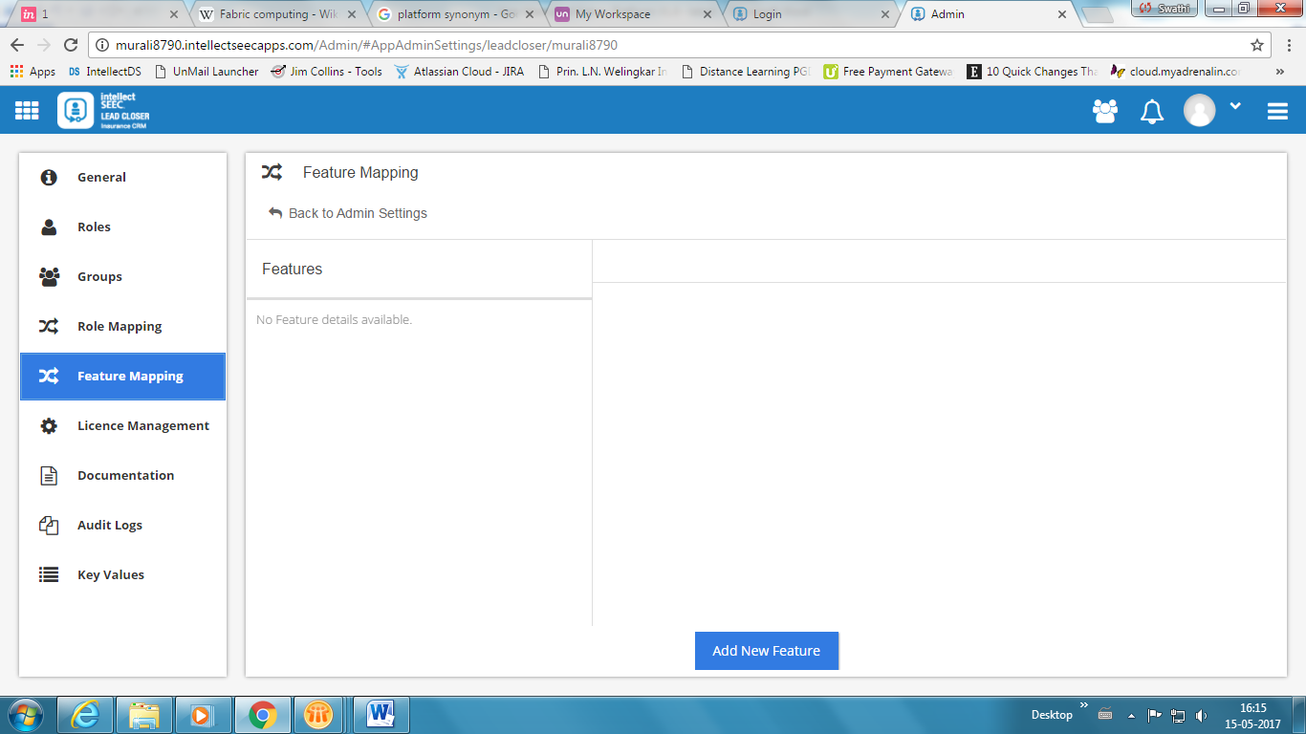

Add name of the feature, Status and ID and then click Save to save the settings configured.

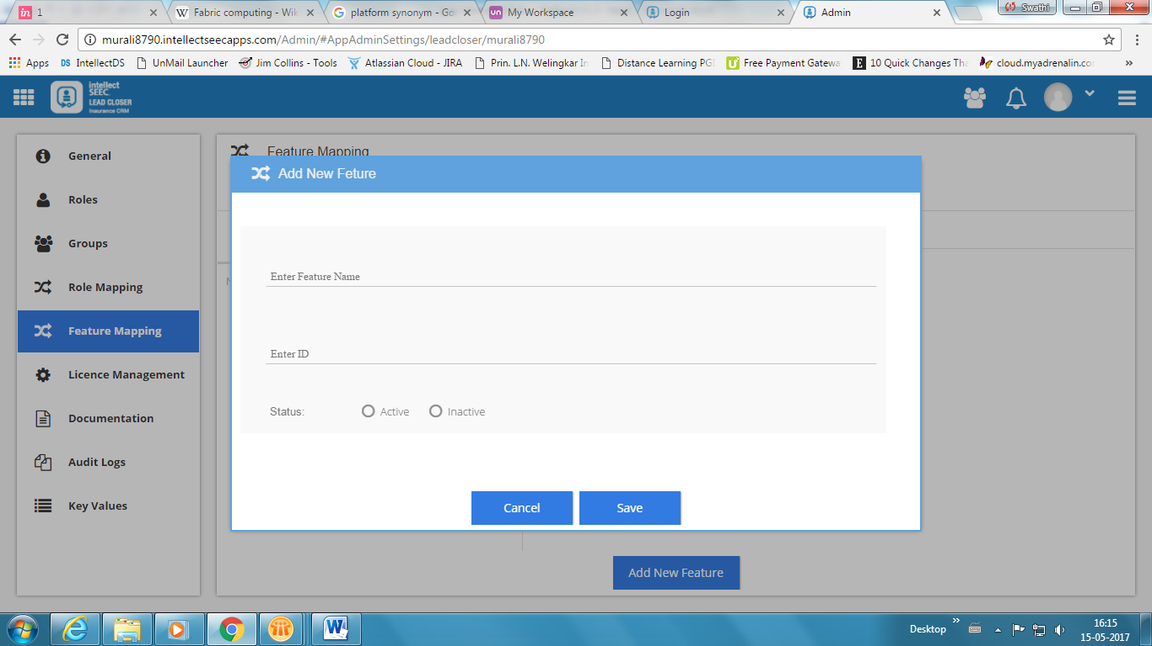

**License Management:**

A contract plan for the app or product taken by the user allowing an individual or group to use the software and adhering to end-user license agreement.

They are four plans set under License Management such as Silver, Gold, Platinum, and Enterprise.

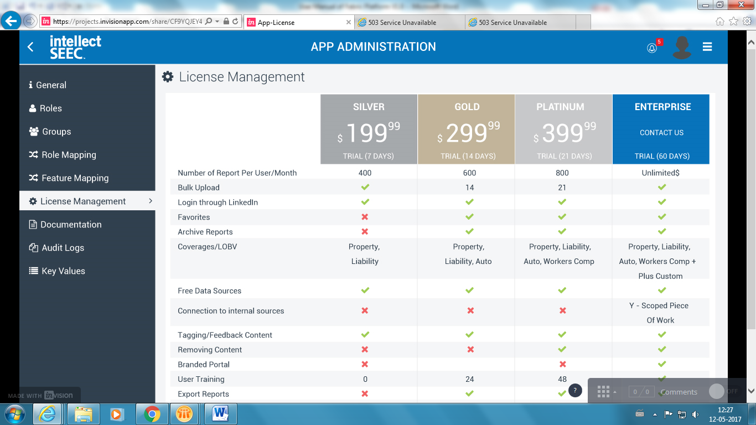

**Audit Logs:**

Audit Logs allows admin to view or track the activities performed by the tenant admins.

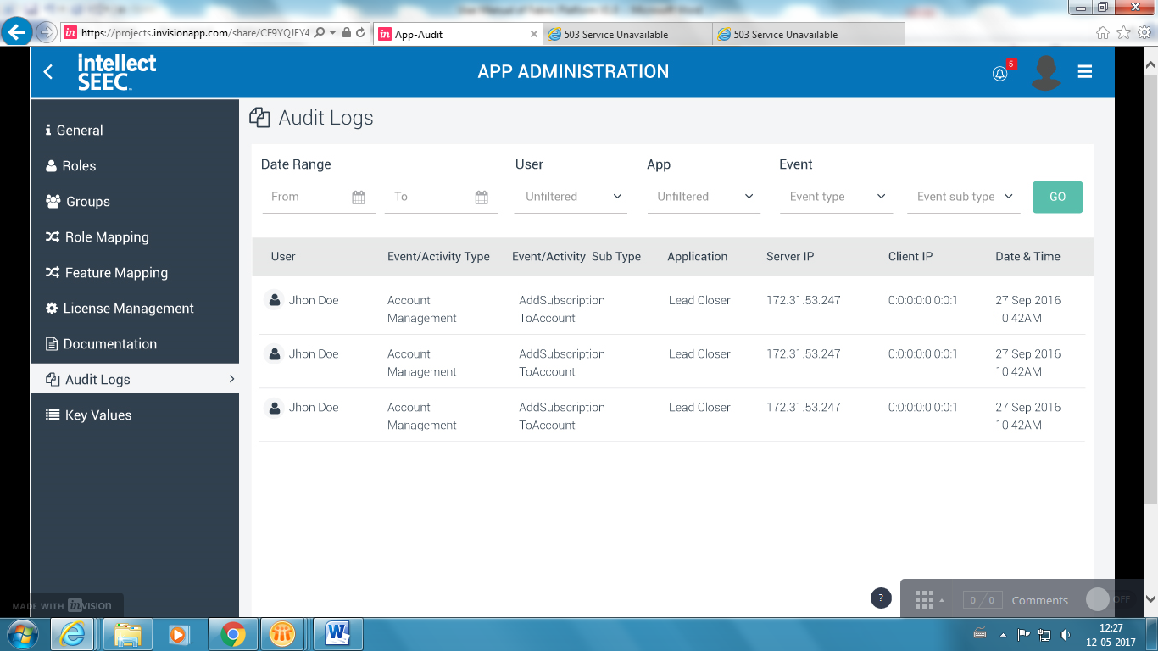

**Key Values:**

Enter key value in number, further it can be treated as unique id for tenant admin to pull up the details when required.

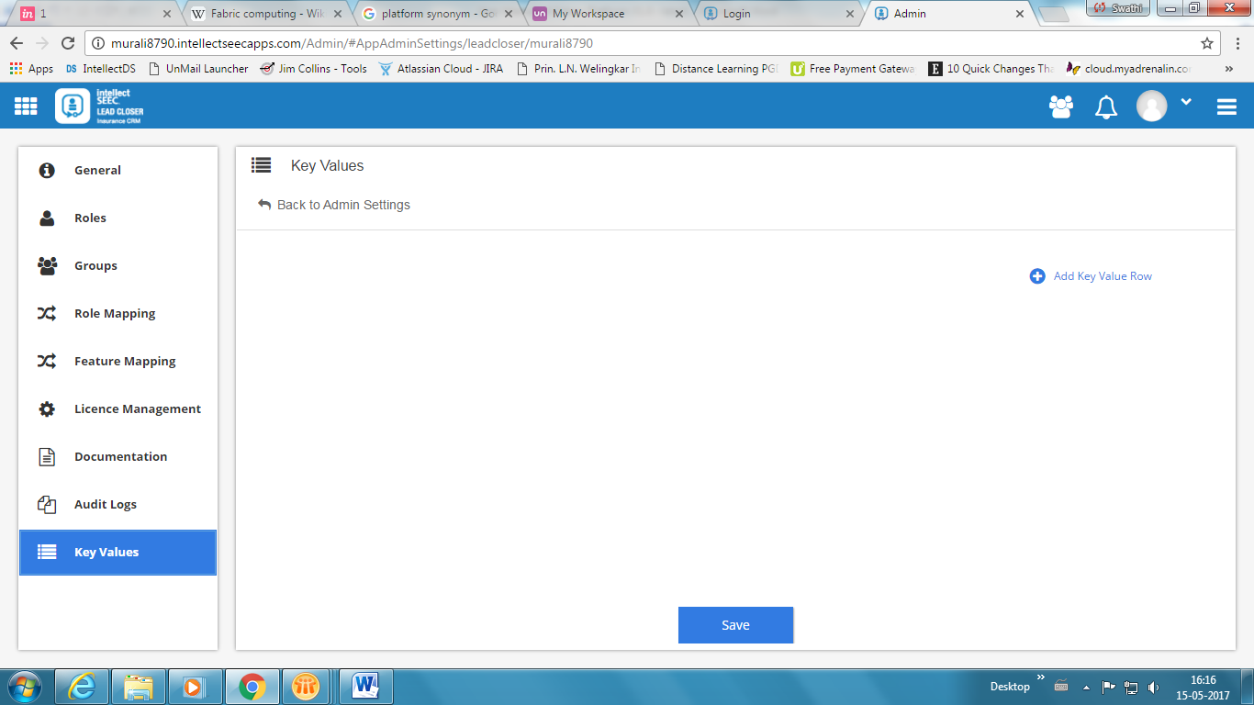

Click Save to submit the data entered.

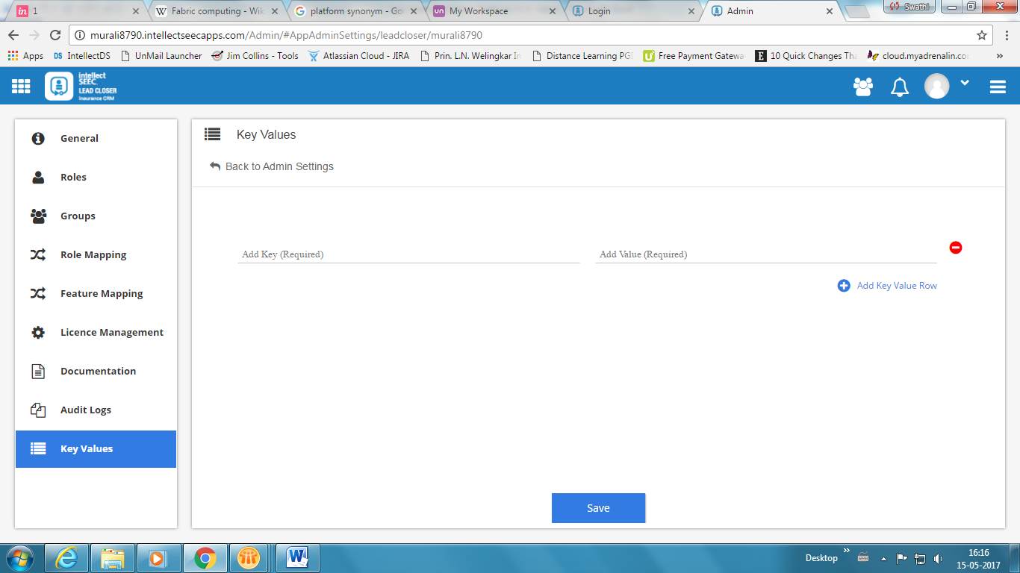

## APIs (Dashboard)

Search APIs consists of pool of APIs; it has a search box and a filter by category. Select the category among Tools, Finance, Other, Location, Business, Social, Data, and Travel, upon selecting the category enter the keyword to search the required API/Program.

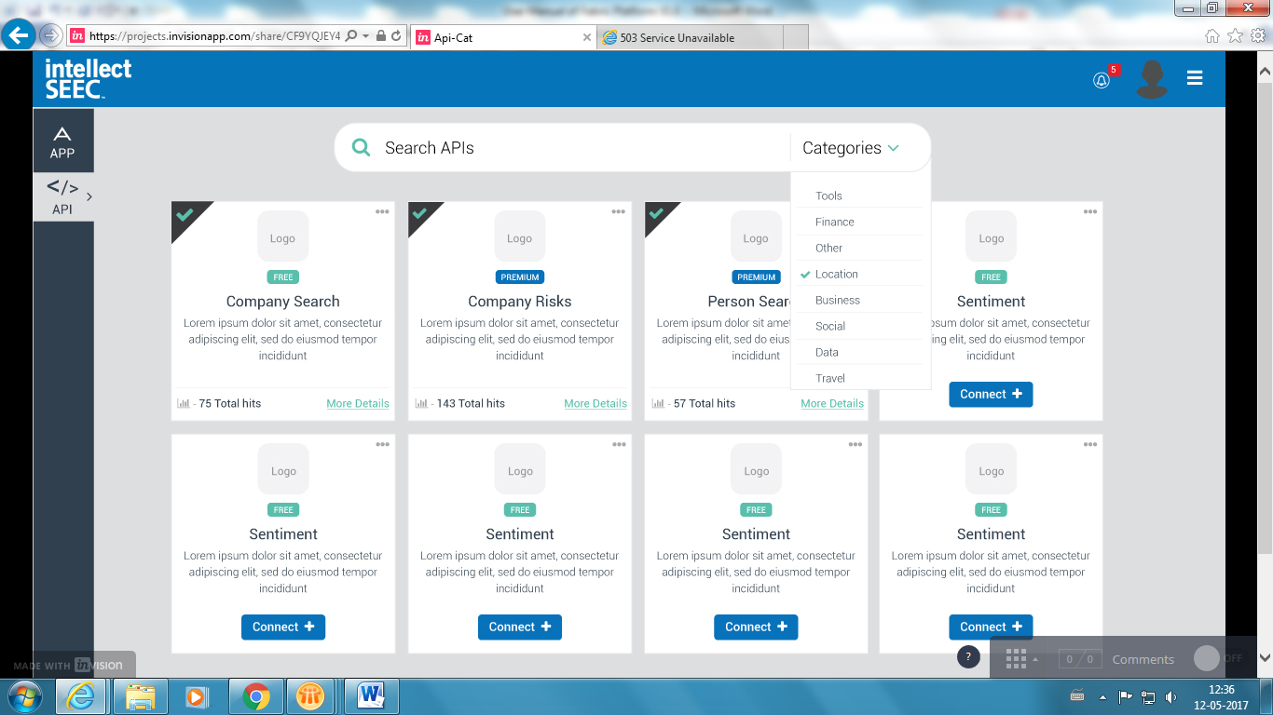

The application gets refresh and shows the results that match with the search criteria.



## System Admin

SysAdmin should enter the below URL to access the application:

URL: <admin.intellectseecapps.com/Login>

SysAdmin is one who understands process requirements and further configures the settings to the users as per the duties or role.

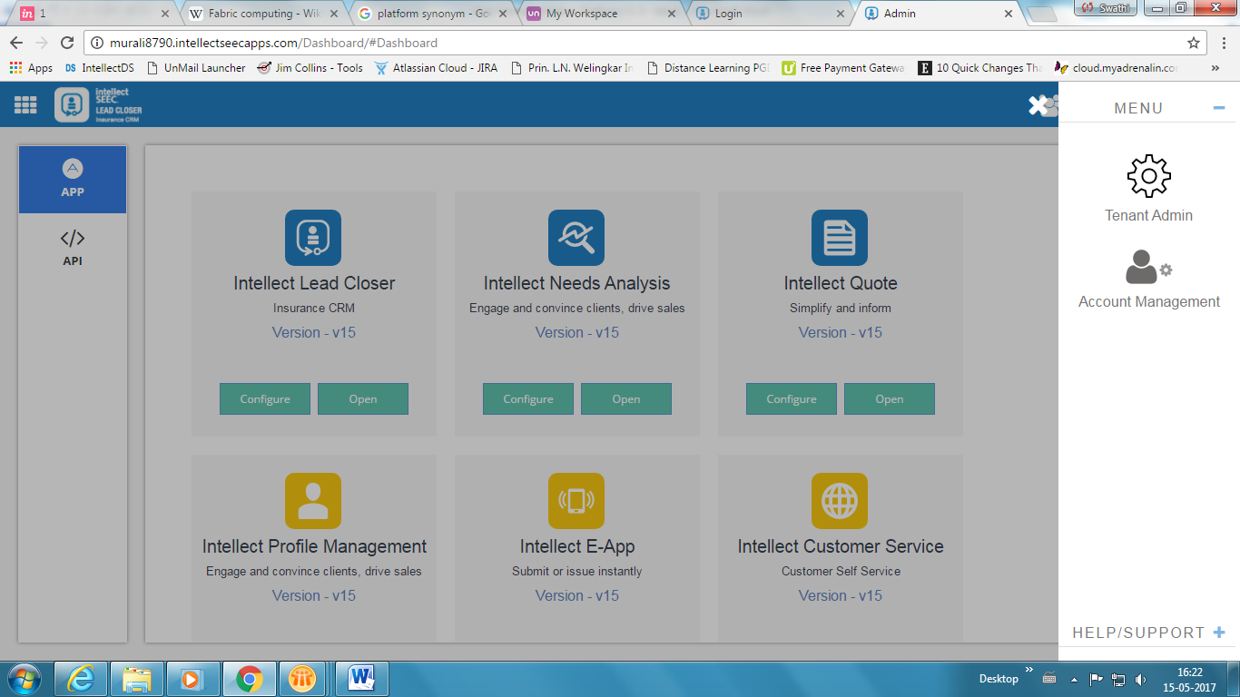

Clicking on SysAdmin the application navigates to System Administration dashboard which helps the admin to take control of Database, Message Queues, Email Settings, Document Server, Security, Social Connect, Applications, Tenants, Notifications, Audit Logs, and Key Values.

**Message Queues:** Send any message to the group user as a queue by configuring at server level. Message Queue Configuration is for handling messages posted to different set of queues and their load configuration.

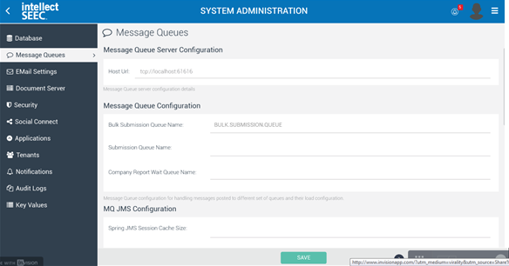

In MQ JMS Configuration enter cache size and redelivery time delay for the message to get posted.

**Email Settings:** Configure the email settings such as SMTP Authentication ID, Password, Transport Protocol, and Port.

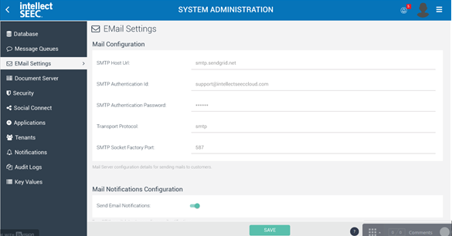

**Applications:** Applications screen shows the list of apps that are accessible and further it allows to **Add New App**.

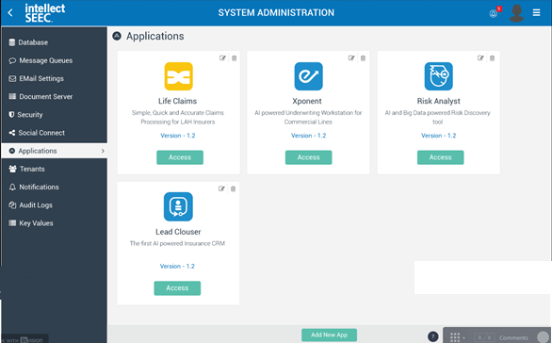

**Tenants:** The list of tenants or the process of giving access to multi-users or clients. On this screen you can search the required tenant by entering the Tenant Email ID in search box provided top right corner of the screen.

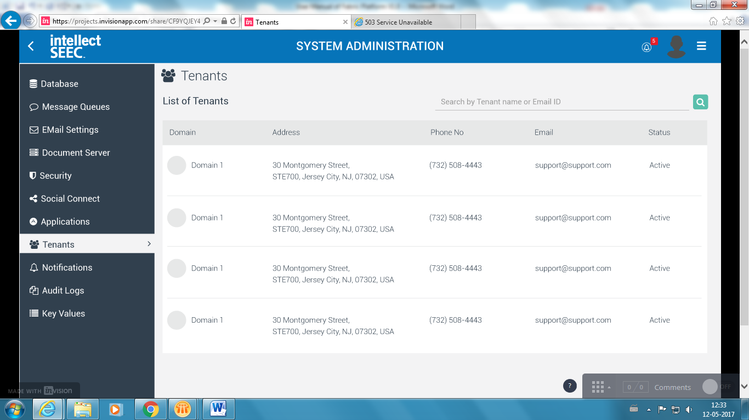

**Notifications:** Send new message to all user as an Application Update or Notification.

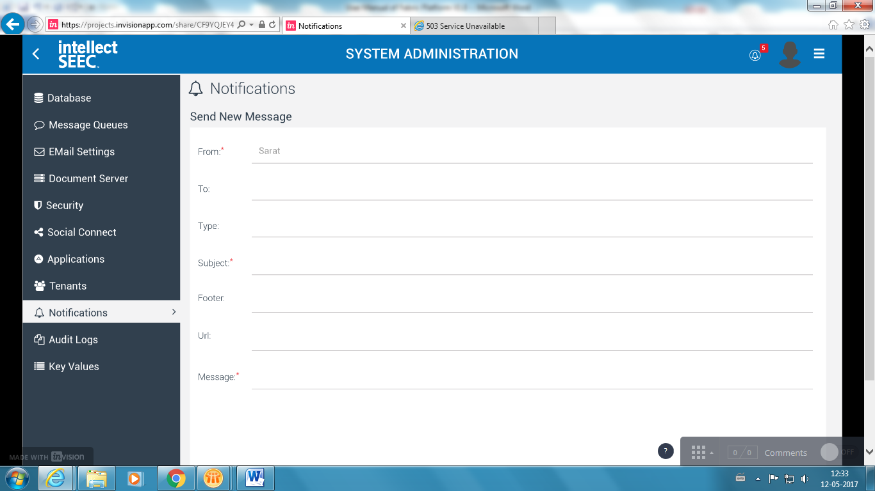

## Tenant Admin

Tenant Admins are the customers who avail our platform services.

**User Management:** Adding user names and passwords to files and folders along with the assignment of rights to access the data.

List of added users gets displayed on User Management screen, enter the required User or Tenant Name or Email ID and further it allows to edit the tenant information, to view audit log/task performed and to send any notification to selected tenant.

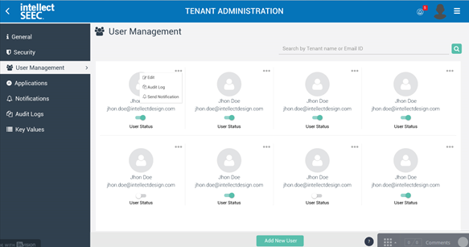

**Applications:** Tenant Admin can access the available applications and also can **Add New App**.

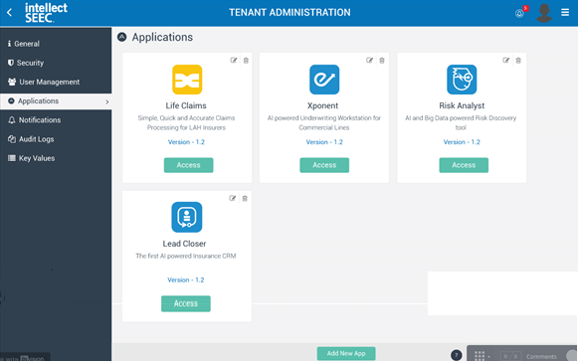

## Account Management

Clicking on Account Management option from the Hamburger menu, the application navigates to API Manager Dashboard screen that consists of My Apps, My APIs, Activities and Billing.

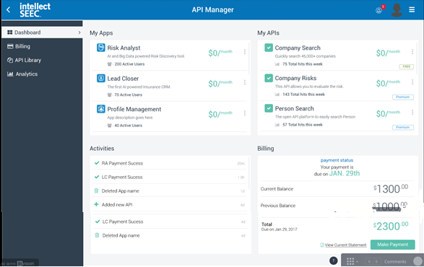

**Billing:**

Billing screen shows the summary of the payment details along with upcoming payments, few common solutions are included such as Bill and Payment Settings, View Bill History by downloading in document format, Schedule a payment for future purposes, and modifying the service plan.

Click Make Payment to pay the current pending amount or dues.

